**Group Project 3**

Qasse, Joanna, Navid, Christian and Chris

1. **Tell a story:**

* Prices of residential properties have been continuing to increase in Australia for the past 30 years, with the strongest annual growth reported in 2021 (~23.7%).
* With upcoming interest rate rises planned for 2022 we sought to inspect the current property market and to look specifically at clearance rates by state, median selling prices per Melbournian suburb and the effectiveness of the various Real Estate agencies that operate in Victoria.
* We aim to use residential property sales data from the past week from Domain.com.au. We hope to create a raft of visuals which will help users see how real estate activity changes in response to economical and political events (such as inflation, wars and interest rate rises).
* Our hope is to produce visuals that will be of use to people looking to make predictions relating to the future behaviour of the property market. Our charts may also inform the purchasing or selling decisions of those that read our project.

1. **Data sources:**

https://developer.domain.com.au/docs/v2/apis will be used to retrieve API data in JSON format.

For data on Melbournian sales completed over last week we will use the endpoint:

[GET /v1/salesResults/{city}/listings](https://developer.domain.com.au/docs/v1/apis/pkg_properties_locations/references/salesresults_listings) (~ 900 property records. Many more than 100 required)

For data on nationwide clearance rates over last week we will use the endpoint:

[GET /v1/salesResults/{city}](https://developer.domain.com.au/docs/v1/apis/pkg_properties_locations/references/salesresults_get)

* API <https://www.domain.com.au> -> schools? *They have this info as well?*
* Vic.gov.au for geospatial information used to set boundaries of VicRoad administrative regions across Victoria
* ???

1. **Project Visuals**

Our group will seek to create a custom D3.js project complete with a dashboard page and multiple charts that update from the same data source.

**Visualisation set 1:** Bar charts. (Managed by Qasse)

**Which is the most effective Real Estate Agency in Melbourne?**

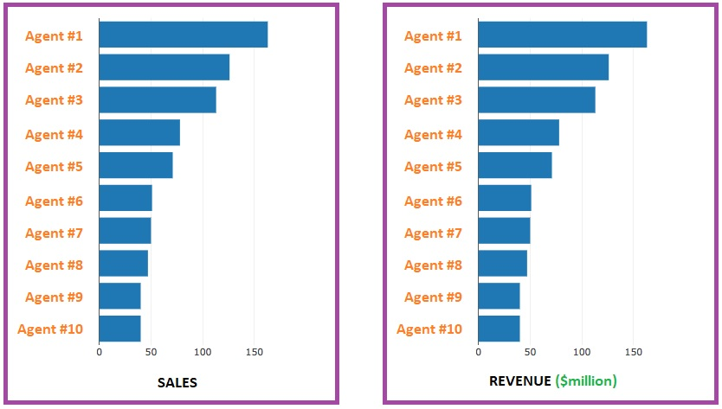

**Visualisation set 2:** (Managed by Joanna and Christian.)

**A study of selling prices in each Melbournian suburb.**

Heatmap with Interactive map (using Leaflet.js) with several layers:

(a) baseMap: lightmap - Visualising the satellite view of Melbourne;

(b) overlayMaps1 - Markers for borders between Victorian councils;

(c) overlayMaps2 - Markers for sold properties, assigned colours depending on price;

(d) overlayMaps3 - Markers for schools in the councils?

(e) overlayMaps4 - Markers and tool-tips displaying each suburb’s median selling price.

A menu will be included so the user can change between Layers.

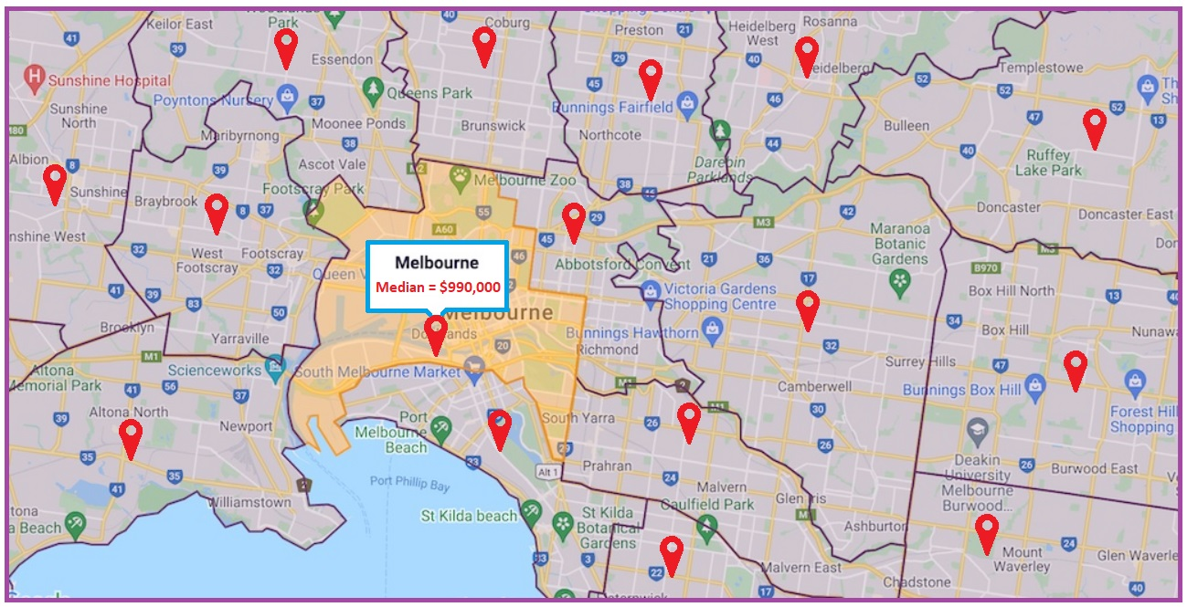

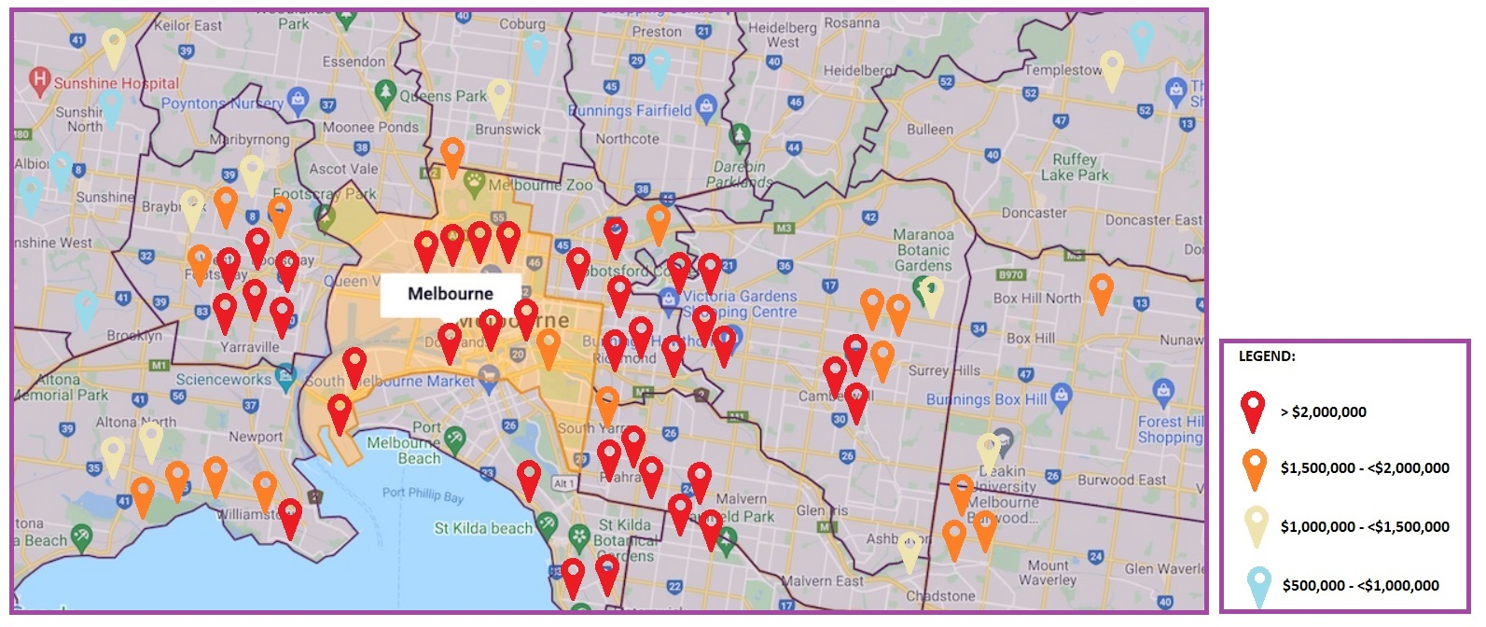

**Visualisation set 3:** (Managed by Chris and Navid)

**A study of clearance rates by capital city.**

For each of Melbourne, Sydney, Brisbane, Canberra and Adelaide a white circle with a radius proportional to the number of properties that were on the market will be assigned. Then each city will be assigned a second smaller purple circle with a radius that is proportional to the number of properties that sold. This will allow comparison between each metric for the aforementioned cities.

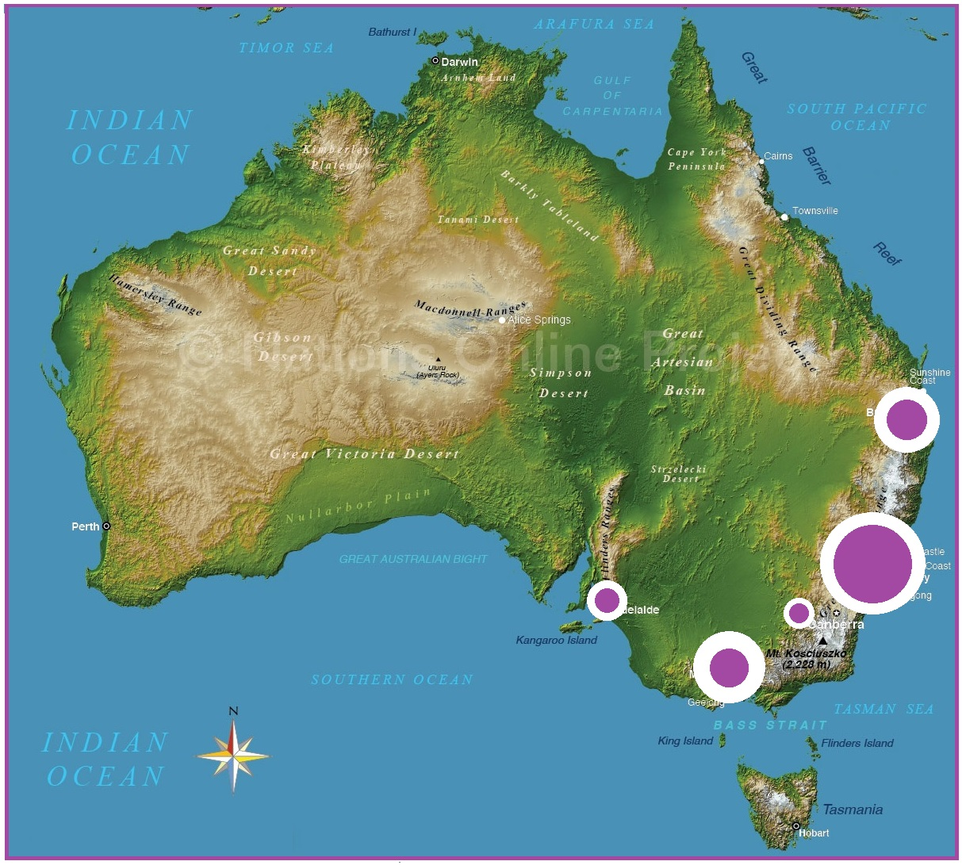

1. **Tools used:**

|  |  |
| --- | --- |
| * Python | * Flask |
| * Domain.com API | * HTML / CSS / Bootstrap |
| * Leaflet.js / Geo-JSon | * D3 |